**Antique 19th Century French Renaissance Revival Over Mantle Mirror**

**Price: $6000**

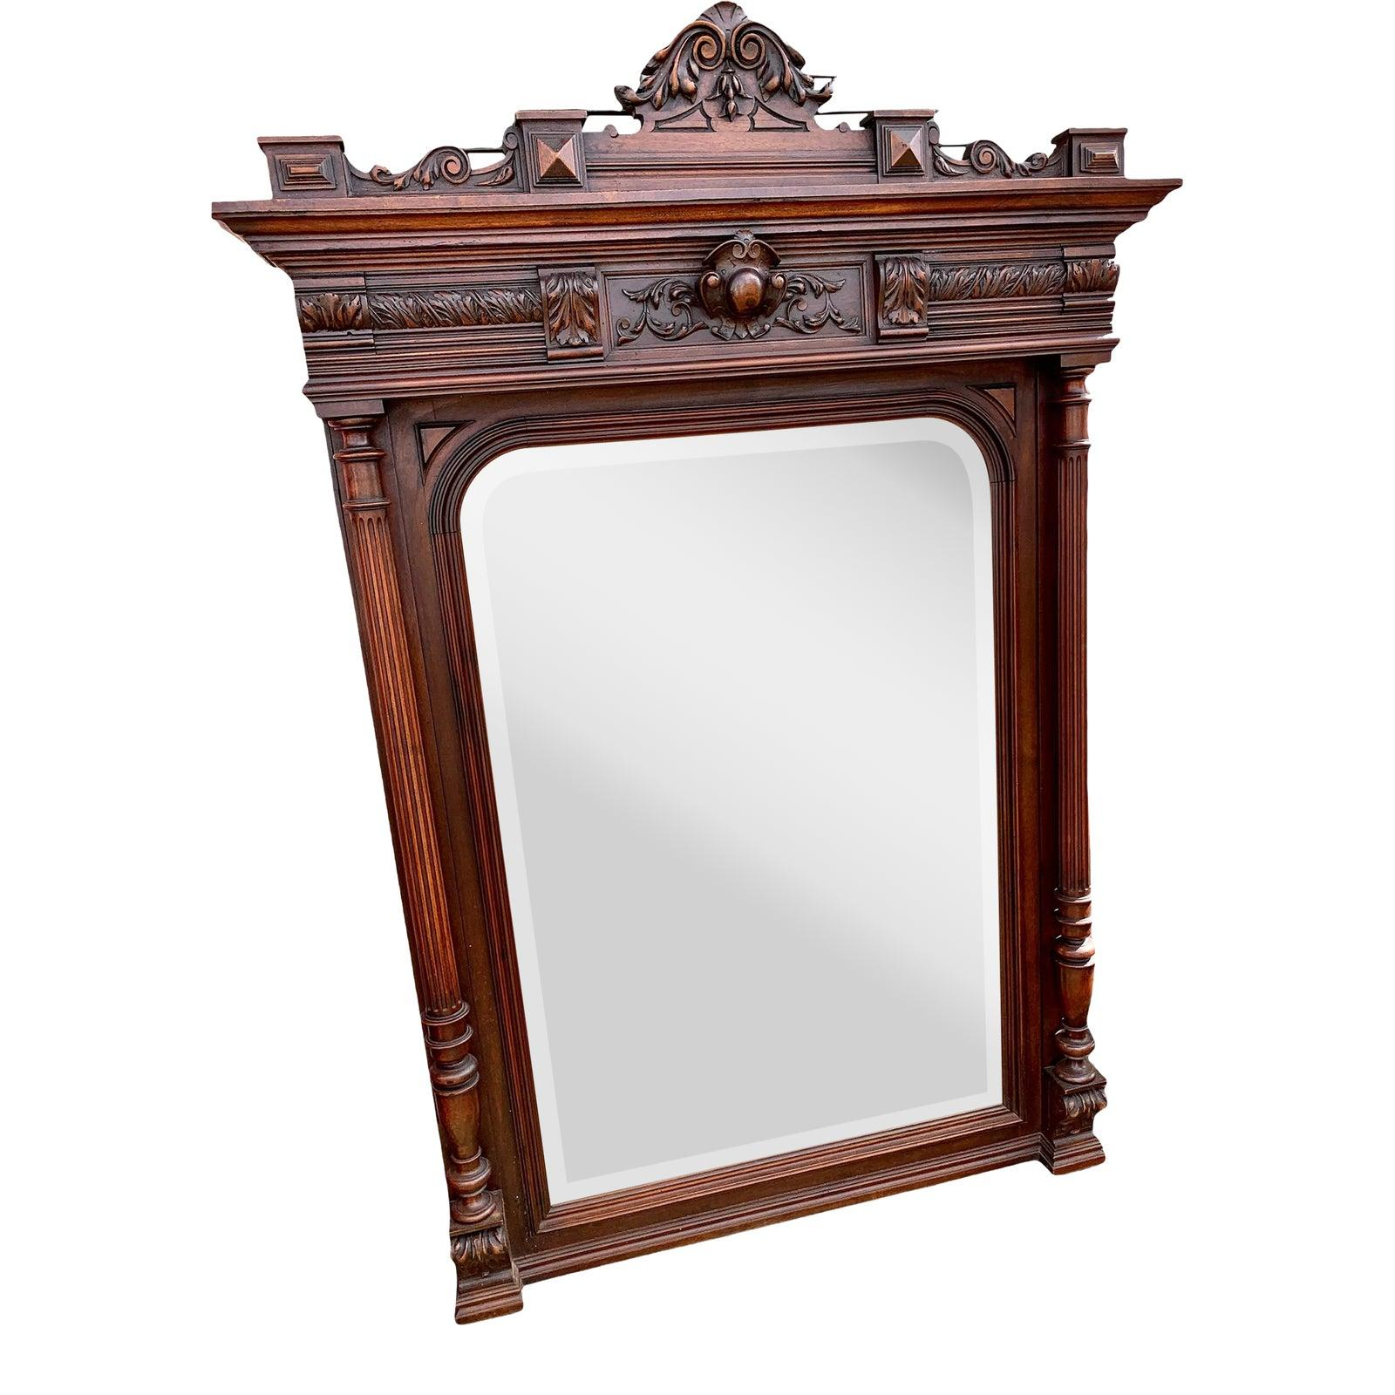

* CATEGORIES

Drawing/Living room mirrors

* MATERIALS

Acrylic Bordered

* SHAPE

Rectangle

* BRAND

Viglacera